Name : K Subrahmanyam
Register Number : 192312521

ITA0602 – MACHINE LEARNING
CO1 AT2 – CONCEPT MAPPING

Question 15
Clustering in Unsupervised Learning – Concept Mapping
Introduction
Clustering is an unsupervised learning technique that groups similar data points into clusters without using labelled data.
(a) K-Means Algorithm
The K-Means algorithm works as follows:
- Select the number of clusters (K).
- Initialize K centroids randomly.
- Assign each data point to the nearest centroid.
- Update the centroid by calculating the mean of all points in the cluster.
- Repeat the process until the centroids no longer change.
Example: Students are grouped based on marks into two clusters.
(b) Elbow Method
The Elbow Method is used to determine the optimal value of K.
Steps:
- Run K-Means for different values of K.
- Calculate the Within-Cluster Sum of Squares (WCSS).
- Plot K against WCSS.
- Choose the point where the graph forms an "elbow."
This gives the best balance between accuracy and simplicity.
(c) K-Means vs Hierarchical Clustering
K-Means | Hierarchical Clustering
Partition-based | Tree-based
Requires K in advance | K not required initially
Faster | Slower
Suitable for large datasets | Suitable for small datasets
Conclusion
Clustering groups similar data without labels. K-Means is fast and efficient for large datasets, while Hierarchical Clustering provides a tree structure for better visualization of relationships.
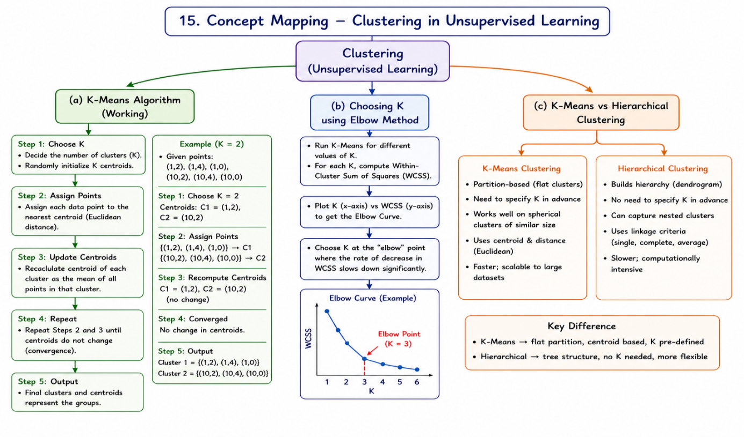

Question 1
Machine Learning System – Concept Mapping
Introduction
A Machine Learning (ML) system is a process that enables computers to learn from data and make predictions or decisions without being explicitly programmed. The ML workflow consists of several stages, starting from data collection and ending with model deployment.
Blocks of a Machine Learning System
1. Data Collection
Data is gathered from different sources such as databases, sensors, websites, surveys, or APIs. The quality of the collected data directly affects the performance of the model.
2. Data Preprocessing
The collected data is cleaned by removing missing values, duplicate records, and noise. Data is also normalized or standardized so that all features are on a similar scale.
3. Feature Engineering
Important features are selected or created from the available data. Feature engineering improves the model's accuracy by keeping only the most relevant information.
4. Model Training
A suitable machine learning algorithm is selected and trained using the prepared dataset. During training, the model learns patterns and relationships from the data.
5. Model Evaluation
The trained model is tested using unseen data. Performance is measured using evaluation metrics such as Accuracy, Precision, Recall, F1-score, or RMSE depending on the problem.
6. Deployment
After successful evaluation, the model is deployed into real-world applications where it can make predictions on new data.
Supervised Learning
Supervised learning uses labelled data, where both input and output are known during training.
Example: House Price Prediction
- Input: Location, Size, Number of Rooms
- Output: House Price
Algorithms:
- Linear Regression
- Decision Tree
- Random Forest
Unsupervised Learning
Unsupervised learning works with unlabelled data and identifies hidden patterns or groups.
Example: Customer Segmentation
- Input: Customer Age, Income, Spending Score
- Output: Customer Groups
Algorithms:
- K-Means Clustering
- Hierarchical Clustering
Conclusion
The machine learning system follows a sequence of data collection, preprocessing, training, evaluation, and deployment. Supervised learning predicts outputs using labelled data, whereas unsupervised learning discovers hidden patterns in data.
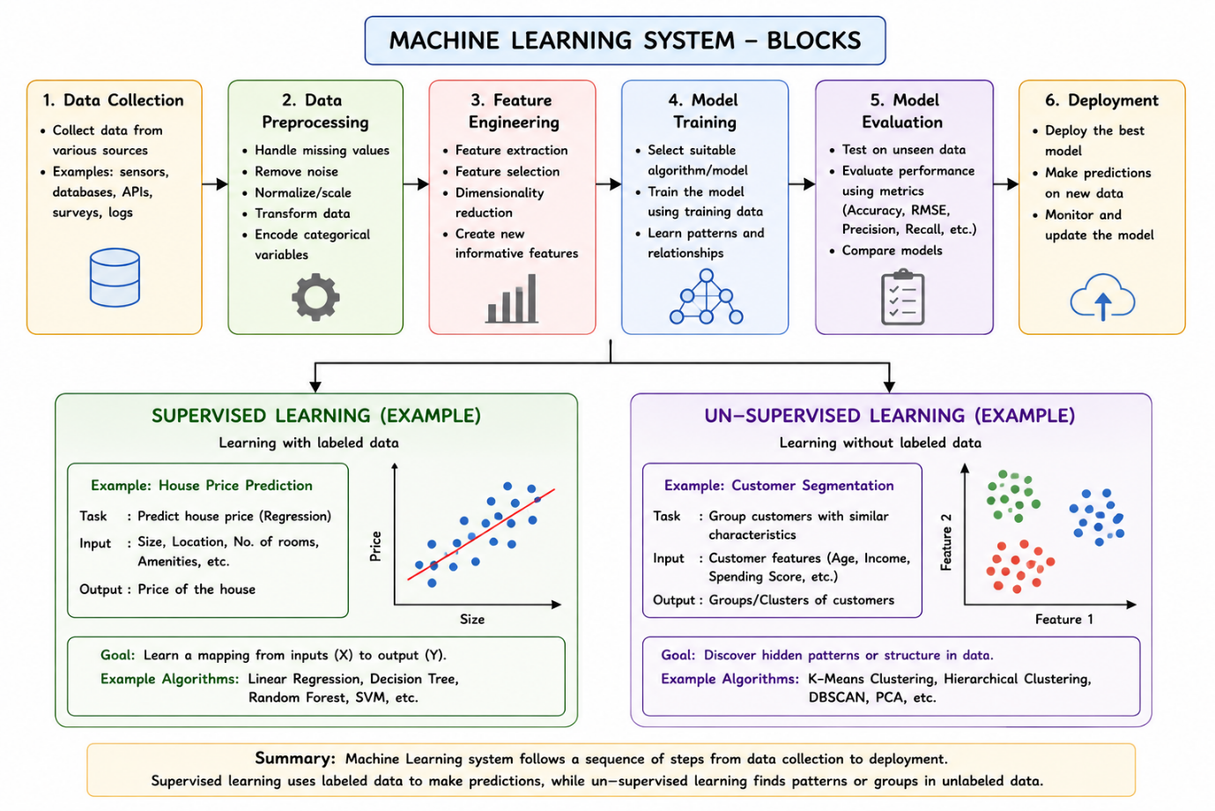

Question 2
Machine Learning System for Disaster Management
Introduction
Machine learning can be used in disaster management to predict floods and earthquakes using historical records and real-time sensor data. Early prediction helps authorities reduce damage and improve emergency response.
Data Collection
The system collects:
- Historical disaster records
- Rainfall and river level data
- Seismic sensor data
- Satellite images
- Weather information
Data Preprocessing
Before training the model:
- Remove missing values
- Remove noise and outliers
- Normalize numerical data
- Convert raw data into usable format
Feature Selection
Important features are selected using:
- Correlation Analysis
- Feature Importance
- Mutual Information
Selected features improve prediction accuracy.
Model Selection
Suitable models include:
- Random Forest
- Gradient Boosting
- XGBoost
These models can accurately predict flood occurrence or earthquake risk.

(a) Training, Validation and Evaluation
Training
The model learns patterns from historical disaster data.
Validation
Validation data is used to tune model parameters and prevent overfitting.
Evaluation
The final model is tested using unseen data.
Evaluation metrics:
- Accuracy
- Precision
- Recall
- F1-score
(b) Early Warning and Emergency Response
The ML system helps by:
- Predicting disasters before they occur
- Sending early warning alerts
- Supporting evacuation planning
- Helping authorities allocate emergency resources
Conclusion
Machine learning improves disaster prediction accuracy and enables faster emergency response, helping save lives and reduce property damage.
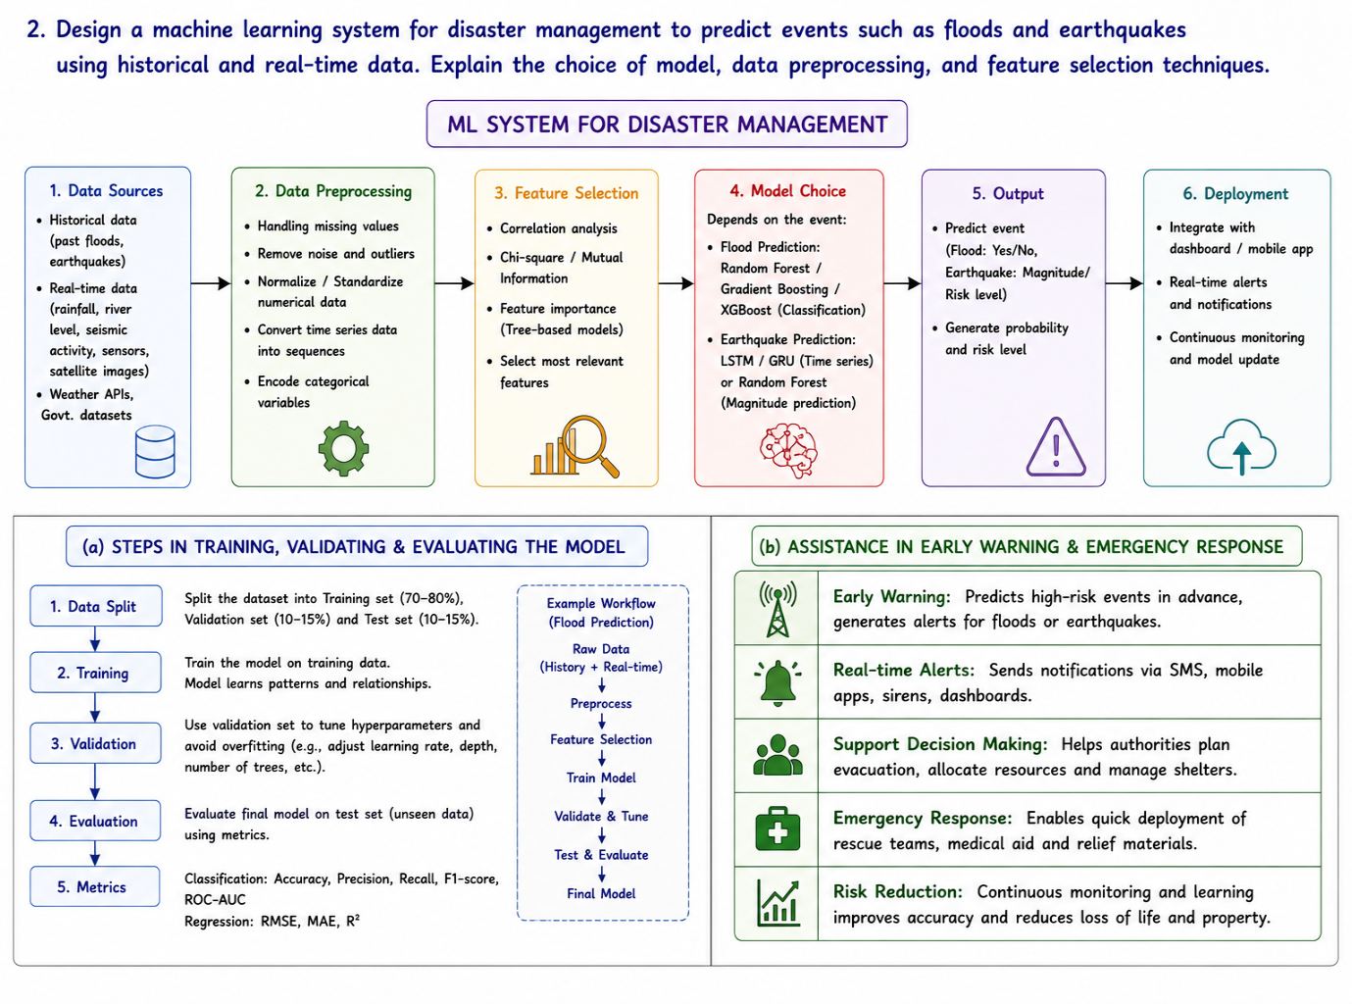

Question 3
Find-S Algorithm – Concept Mapping
Introduction
The Find-S algorithm is a supervised machine learning algorithm used to determine the most specific hypothesis that covers all positive training examples. It ignores all negative examples.
Working of the Find-S Algorithm
Step 1
Start with the most specific hypothesis.
H₀ = ⟨Ø, Ø, Ø, Ø⟩
Step 2
Read the first positive example.
Replace each Ø with the corresponding attribute value.
Step 3
Read the next positive example.
If an attribute differs from the current hypothesis, replace it with ?.
Step 4
Repeat the process for all remaining positive examples.
Ignore all negative examples.
Step 5
The final hypothesis is obtained after processing all positive examples.
Advantages
- Simple and easy to implement.
- Learns only from positive examples.
- Produces the maximally specific hypothesis.
Limitations
- Ignores negative examples.
- Sensitive to noisy data.
- Works only when the target concept is represented by conjunctive hypotheses.
Final Hypothesis
After processing all positive examples, the final hypothesis is obtained by replacing conflicting attribute values with ?.
Example:
H = ⟨ ?, ?, ?, ? ⟩

Conclusion
The Find-S algorithm starts with the most specific hypothesis and gradually generalizes it by considering only positive training examples. It produces the maximally specific hypothesis that is consistent with all positive examples.
